Time Based OTP

Contents

1.TOTP generation   
 2.TOTP usage

1.TOTP generation

a. Launch Time Based OTP User Identity Binding using below URL and click on sign in with esignet.  
 <https://totp-binder-service.onpremdev.idencode.link/>

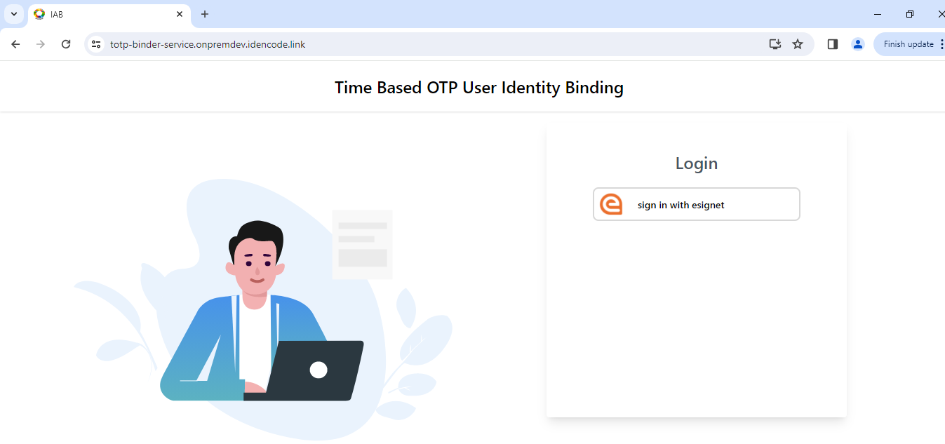

b. Click on **Login with OTP**

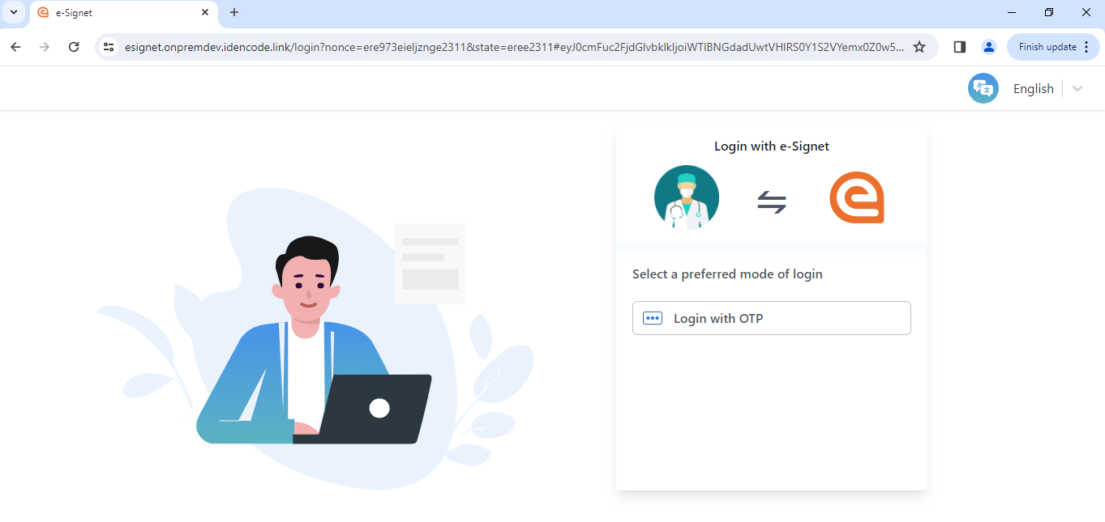

c. Provide UIN and click on Get OTP

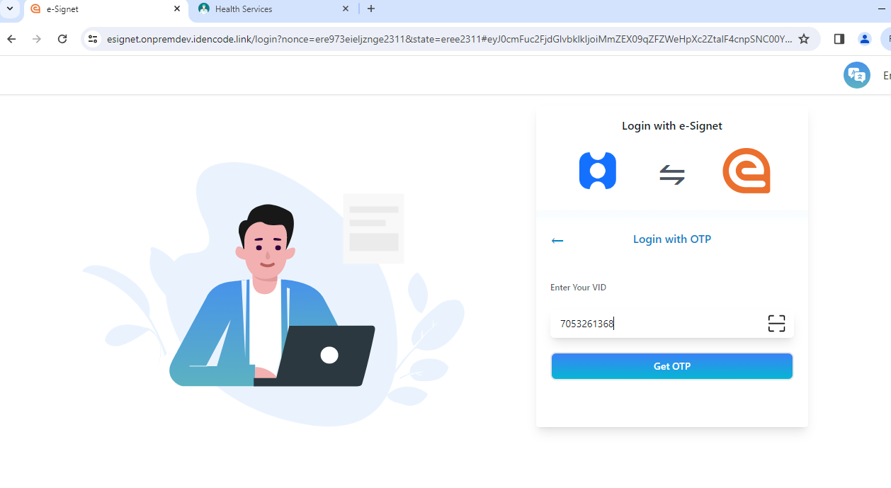

d. Enter static OTP 111111 and click on Verify. It will redirect to consent page.

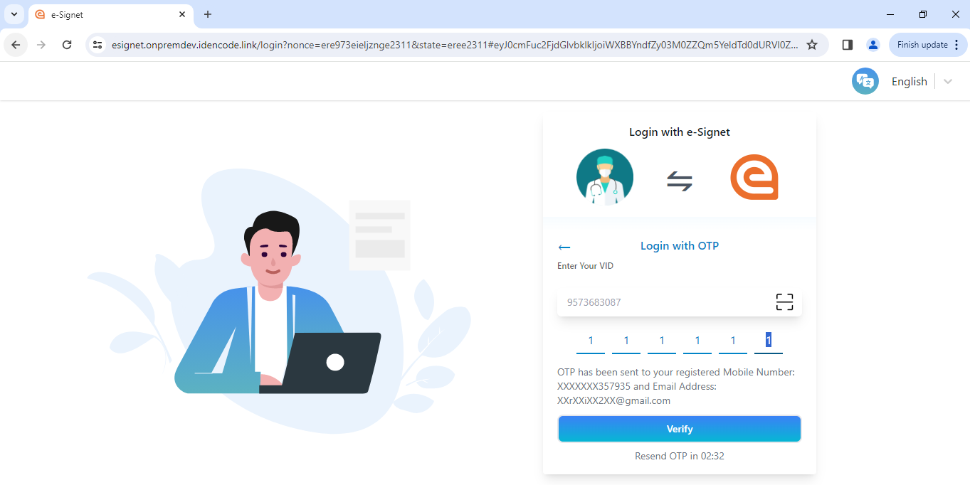

e. Enable voluntary claims and click on continue.

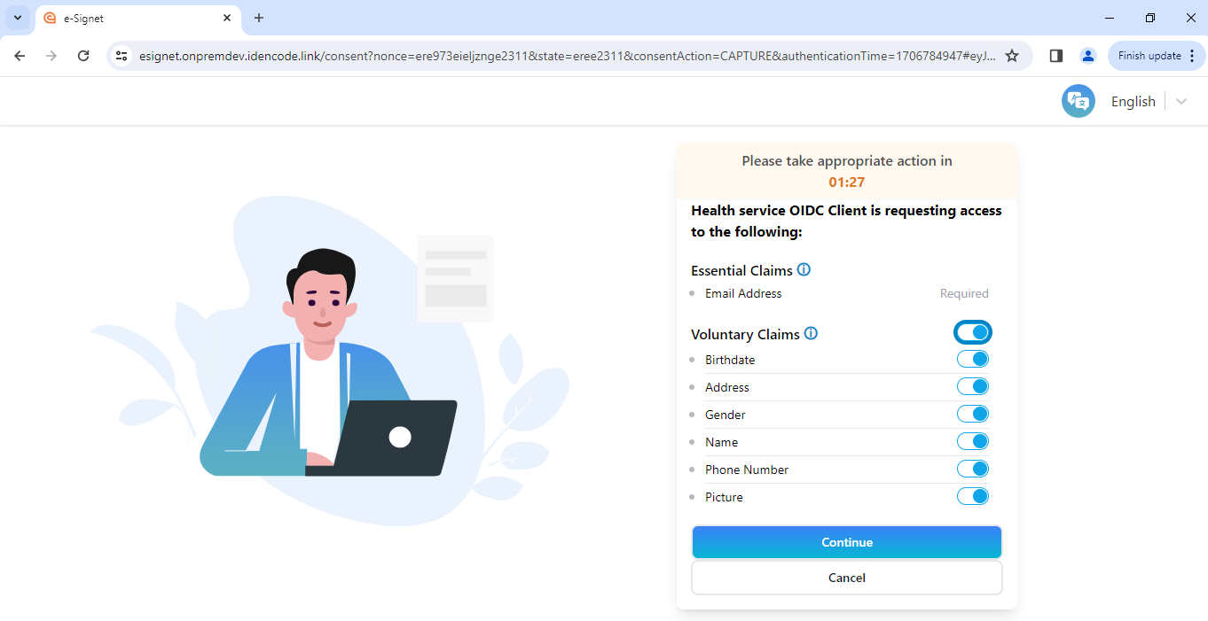

f. Once log in is successful, click on Generate QR Code.

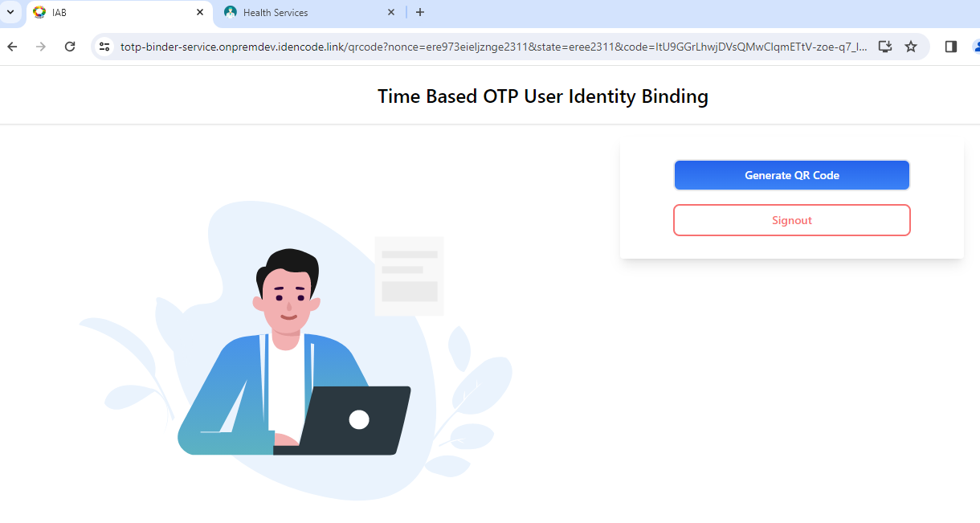

g. QR Code is generated.User can regenrate QR Code multipule times by cliking on regenrate QR Code.

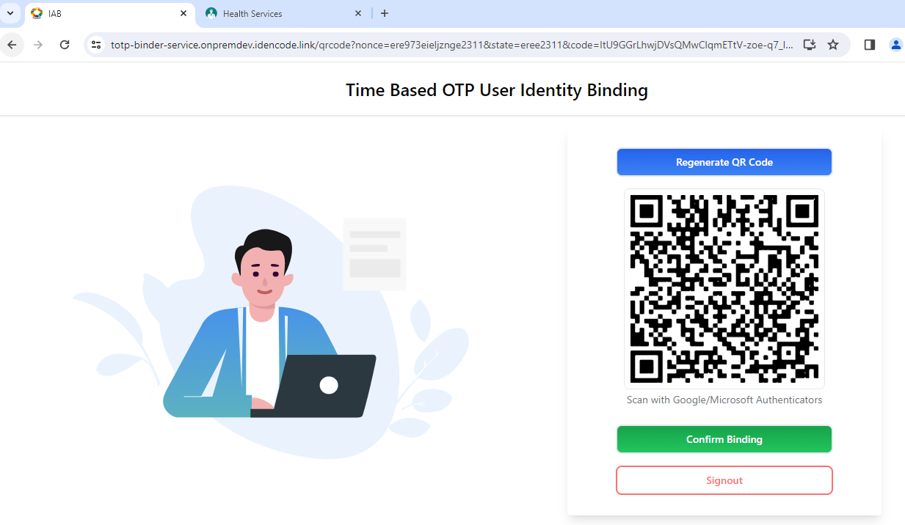

h. Scan the QR Code using google authenticator / Microsoft authenticator to get the TOTP

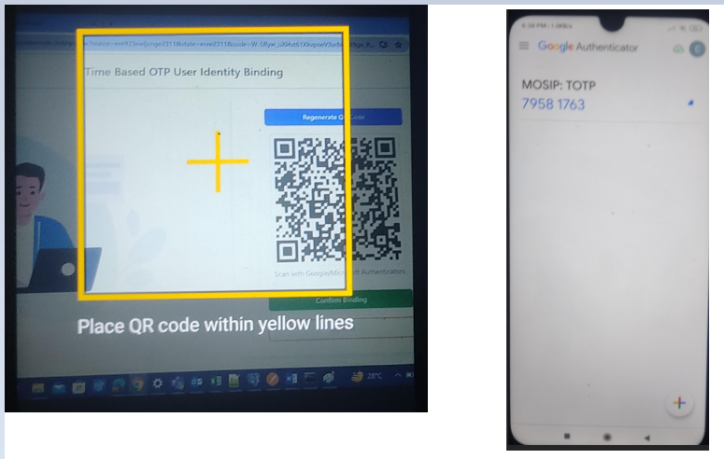

i. Click on Confirm Binding. The UIN will be bound to the key.

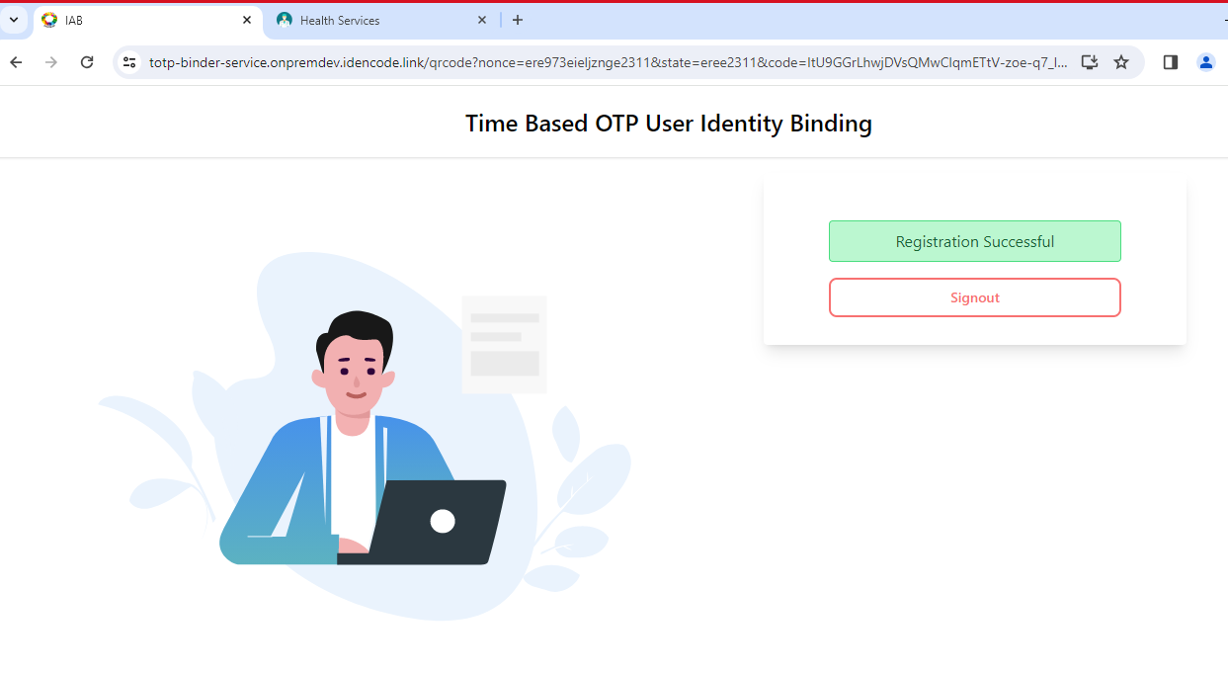

j. Click on signout to log out from Time Based User Identity Binding.

2.TOTP Usage

1. Open health services portal using below URL and click on Sign In with e-Signet   
   <https://healthservices.onpremdev.idencode.link/>

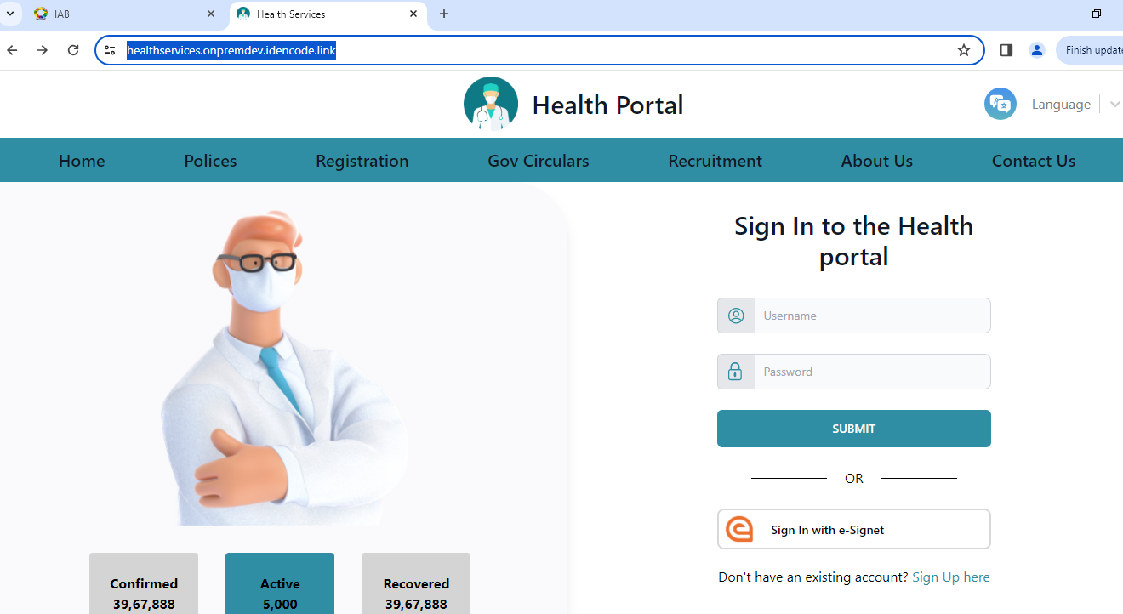

1. Select **Login with TOTP**. It will redirect to where user can enter totp.

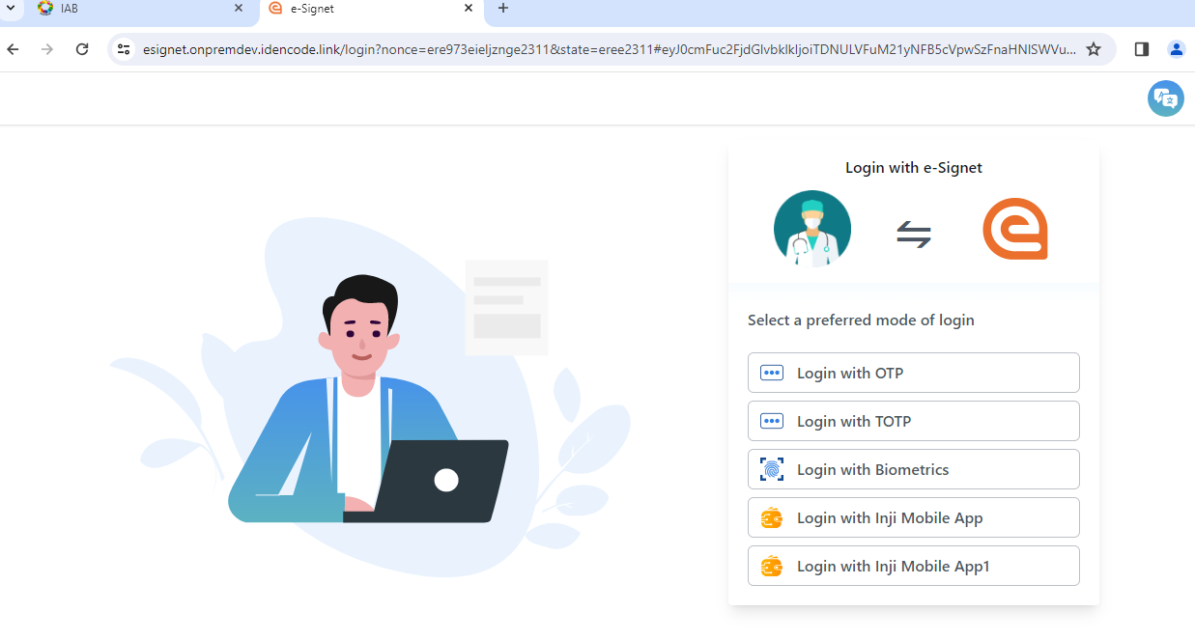

1. Provide UIN, Valid TOTP and click on verify   
   Note:- Every 30 seconds TOTP will be regenerated by default.

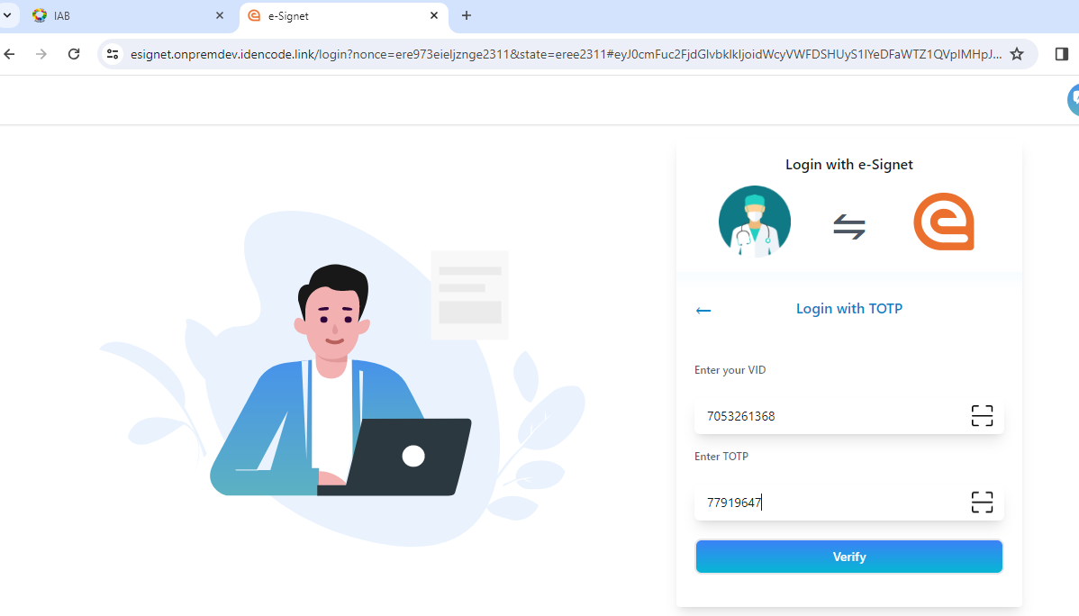

1. Enable Voluntary Claims and click on continue

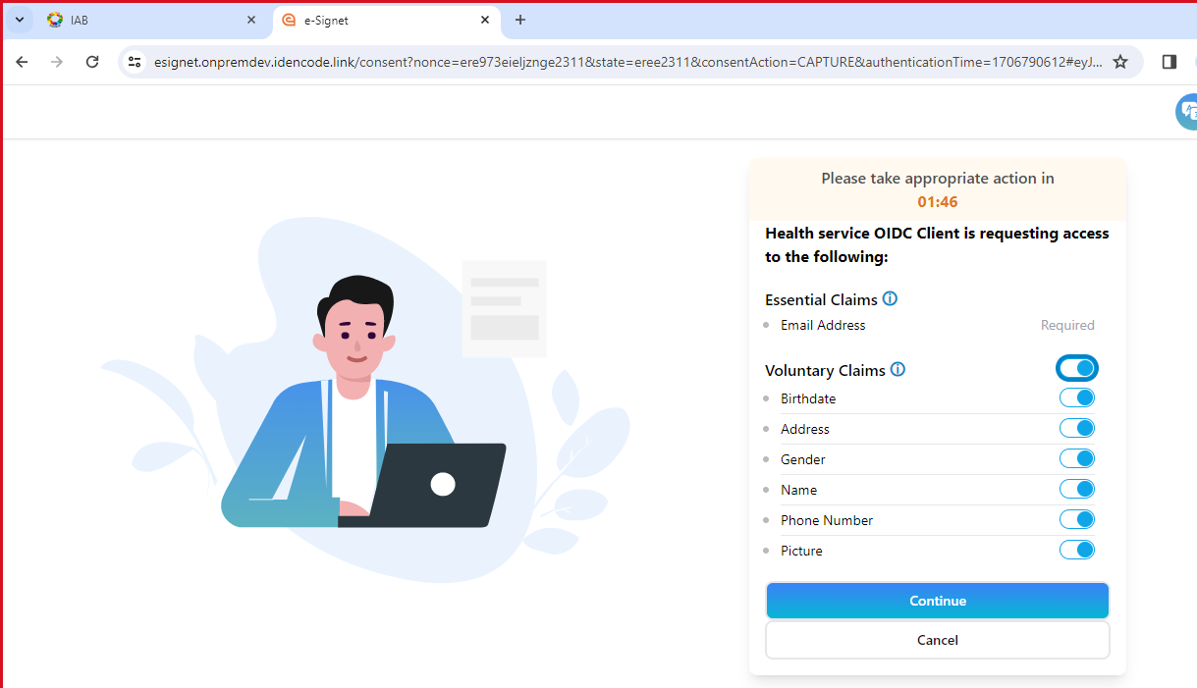

1. TOTP login successful.
2. 